

# 2. Project Summary

In spite of current quality assurance measures, airlines spend billions of dollars a year on mishandled luggage. This includes the funding to support the extra personnel to transport the bags to the individuals and also to reimburse travelers who’s bags have been lost. We seek to alleviate that cost.

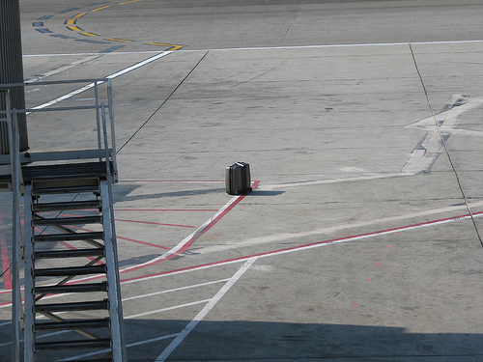

To solve this problem a better quality assurance system needs be placed. The system should have more checkpoints to pinpoint the exact location of errors. Since 61% of all mishandled bags are caused by transfers, areas involving transfers should be the main focal point.

AIR Tracker accomplishes all of the above and more. In addition to the checkpoints current quality assurance systems have (check-in and sorting), AIR tracker is able to track bags when they are loaded and unloaded from the cart which is crucial during transfers. Not only does the system track the bags, it can also sense when a bag has strayed away from the cart and can safely alert the driver. Furthermore, the cart scans would eliminate the need of scanning the bag at the bottom of the belt loader thus effectively reducing the time for all flights, including transfers.

1) In this case, “mishandled” means dropped, left behind, or mistakenly sent to the wrong area or plane.

# 3. Project Description

**3.1 The Problem**

Mishandled luggage costs the airline industry as a whole $4 billion a year. Returning mishandled luggage wastes the time of both customer and airline.

Customers can become frustrated after their bag is mishandled for several reasons. For example, if the customer is a on a business trip and has uniform inside his or her bag, that person may give a bad appearance and lose reputation. Or it may just be that the person needs necessities such as medicine or underwear.

Airlines also suffer from mishandled bags. They have to hire more personnel and buy more resources to remedy the problem. Mishandled luggage may even deter return customers.

**3.1.2 Statistics**

The following statistics from various organizations illustrate the magnitude of the problem.

* In July 2007 British Airways mishandled an average of 28 checked bags per 1000 passengers. - AEA (Association of European Airlines)
* In August 2008, bags were mishandled at a rate of 8,700 a day by American-based airlines. - U.S. Department of Transportation

“If an airline [mishandles] a passenger’s bag, you raise the possibility of losing the customer for the long term.” Billions in lost revenue and wasted man-hours takes away from the customer-oriented business of air travel.

**3.1.3 Increase of Mishandled Bags**

The problem isn’t stopping either. More people are flying, yet little has changed in the airport systems to handle the increase. The following graph exemplifies the increased rate of mishandled baggage by U.S. Airlines. Many other large airlines suffer from a similar increase.

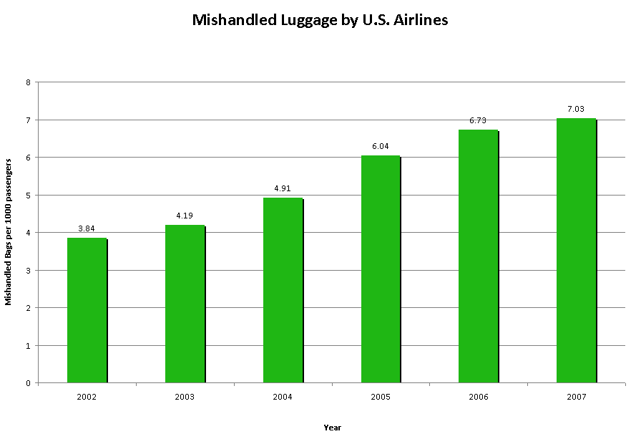

Along with the ever increasing population, more and more regulations are being placed which further attribute to the cause of increase in mishandled bags. Martin Broughton, ex-Chairman of British Airways, said “The government’s insistence on only one piece of hand luggage… has put huge strain on the baggage handling staff and, yes, is therefore to blame for the lost luggage.”

**3.1.4 Causes of Mishandled Luggage**

The graph below shows the percentage of mishandled bags grouped by the general cause. The numbers within this graph will be referenced upon frequently due to the importance of this data.

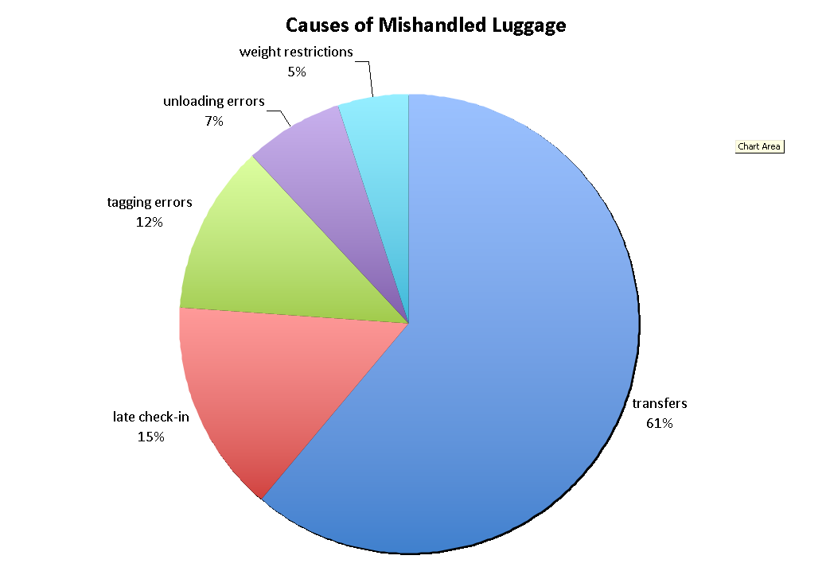

“The primary reason behind mishandled bags is delayed and misconnected flights.” said David A. Castelveter, an Air Transport Association spokesman. As you can see, over sixty percent of mishandled bags are indeed caused by transfers, followed by late check-ins, tagging errors, unloading errors and finally weight restrictions. Transfers are the biggest problem simply because there is not enough time to move the bag from one gate to another. Late check-ins would also delay the bag’s travel. Tagging errors are currently being fixed by replacing barcodes with RFID technology. Unloading errors can be fully amended with a good solution. Weight restrictions is the only cause of mishandled baggage that cannot be fixed.

**3.1.5 An Expert’s Words**

To find a more specific cause of mishandled baggage, team member Ashley Casper went to Norfolk International Airport to talk to Gloria Anderson, an expert in the baggage handling field. Of the many insights Mrs. Anderson had give us, these quotes were critical.

* “Baggage handlers drop more bags [off a cart] than they put baggage on the wrong flight.”
* “We’ll never know how many bags, when found to be missing from a flight, make it onto the right plane. Those statistics aren’t calculated.”
* “The carry-on versus checking issue is becoming more important because people are cheap. They refuse to check bags, but now, airlines can get fined thousands of dollars if a passenger carried more than two carry-ons onto a plane.

With these quotes, one can assume there is no scanning at the belt loader. Also, it is clear that bags that fall off the cart are a problem.

**3.2 The Solution**

**3.2.1 Solution Introduction**

A custom-suited AIR Tracker will augment existing systems at airports utilizing technology that already exists. Using the existing RFID antennae and bar code scanners that register the bag’s location, AIR Tracker will track and report on the routing of luggage in airports as well as offer a real-time account of luggage statistics on the luggage carts. AIR Tracker will provide comprehensive reports to assist the airport in pinpointing problem areas in their handling process, thereby reducing the amount of mishandled luggage.

SITA’s CEO, Francesco Violante once said, “Even small improvements in the amount of baggage ending up at the right place at the right time could save the air transport industry hundreds of millions of dollars a year as well as millions of passenger hours that could have been spent doing something much more productive than trying to retrieve mishandled bags.” AIR Tracker is a tool that is used to find trouble spots where “small improvements” can be made.

Air Tracker solves a lot of problems, but there are some things we do not intend to cover. We don’t provide personnel to manage the system, we only provide training. Also, our solution cannot be liable for any stolen bags.

**3.2.2 The Five Checkpoints**

AIR Tracker uses five well placed checkpoints to gather data.

1. Check-In
2. TSA Inspection
3. Loading the pusher
4. Unloading the pusher/Loading the cart
5. Unloading the cart (bottom of the belt loader)

The first three checkpoints will be provided from the existing baggage handling system while checkpoint 4 and 5 provided by us with the use of cart sensors and wireless antennas.

The following picture illustrates the five checkpoints.

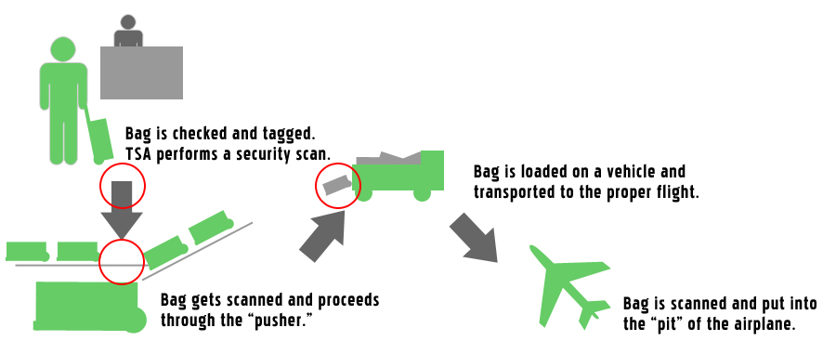

**3.2.3 Process Flow**

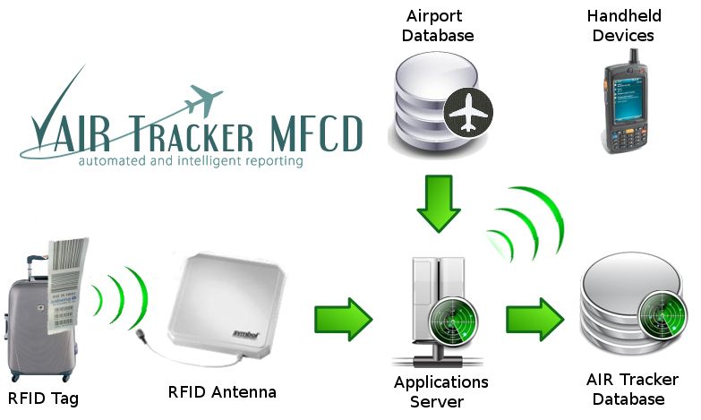

The diagram above displays the flow of data throughout major components of the project.

When a bag passes through a checkpoint, it is scanned by a RFID or barcode scanner. The data is then sent to an applications server via high speed Ethernet cables. The applications server continuously gathers data from both the airport database and antennas. At this point, the server may be used to send real-time alerts to other devices about mishandled bags. It then combines the data to create useful information and stores it in the AIR Tracker Database.

**3.2.4 Cart Antenna**

If a bag is dropped from the cart, it is not noticed until the cart reaches the airplane, which by that point (depending on the size of the airport), it may be too late to go back and get it before the plane departs.

The RFID baggage cart antenna communicates wirelessly (via WiFi) with the Airport’s WiFi antenna to gain updates from the master database on which bags should be on which flight. The cart also has onboard memory and firmware to temporarily store the data of the bags in the cart. The RFID Cart antenna actively pings the RFID tags on the bags in a cluster method. If one of the bags is returning a distinctly longer ping response, the antenna alerts the driver that a bag has fallen off. The driver then has time to stop and regain the dropped bag.

An RFID gate on the ramp reads the bags that are loaded on the airplane and sends an alert to the handlers if there is a bag that is not meant to be on that plane. The gate is updated wirelessly from the airport as well. This serves as a final redundancy to the RFID system.

**3.3 Market**

**3.3.1 Target Customers**

Airports of all sizes can benefit from AIR Tracker, but the primary targets are airline hubs with RFID. An airline hub is an airport that an airline uses as a transfer point to get passengers to their intended destination. This is an airport where many transfers take place and where many bags are mishandled. To further specify the target, hubs with high rates of mishandled bags.

Since AIR Tracker is targeted at airports, the team will utilize personal marketing visits in order to market the product. The team would have to negotiate with the heads of the airport who would in turn talk to the airlines. The cost for the product would be shared by airlines and shops and other airport venues via higher lease fees.

Smaller airports will be used for beta testing. Success at these sites will entice larger airports to purchase AIR Tracker. The team can then try to get sponsored from large organizations to further advertise our success.

**3.3.2 Competition**

After we analyzed the current market for a drowning detection system such as ours, we then looked at our potential competitors. FKI Logistex, Logan Teleflex, and Vander-Lande all provide baggage handling systems along with software that allows the customer to see the status of a bag using the bare three checkpoints. Although the competition helps to solve each facet of the mishandled luggage problem, AIR Tracker supplements their capabilities.

WorldTracer on the other hand offers a comprehensive airline information management system for mishandled property, similar to the AIR Tracker. This makes WorldTracer our main competitor and also makes competition a huge risk.

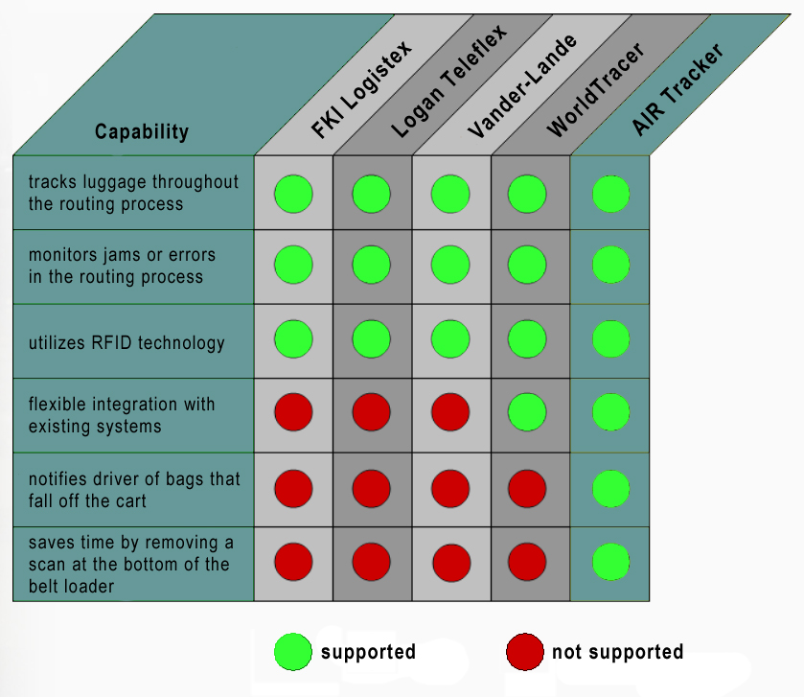

**3.3.3 Niche**

AIR Tracker rises above the competition mainly due to the three features shown above. Along with WorldTracer, AIR Tracker is able to integrate into existing systems with minimal modifications. It will be custom made for each airport. The two features that none of the competition has revolves around the cart module. The first feature being the notification to personnel when a bag has fallen of the cart and the second being the time saved by removing the bottom belt scan.

**Product Potential**

* The cost of returning a mishandled bag to its owner, including fuel, manpower, and ground transportation costs, is estimated at around $90 by the International Air Transport Association.1 Airlines currently lose approximately seven bags per 1000.
* Southwest Airlines, for example, flies over 104 million passengers a year.2
* That would conservatively equal approximately 728,000 mishandled bags a year, costing $65.5 million.
* If only three bags were lost per 1000, airlines would save almost $40 million.
* Saving one bag in 1000 saves almost $10 million.

**3.3.4 Solution Characteristics & Benefits**

To summarize the solution all of the benefits of AIR tracker are listed below.

AIR Tracker will…

* be able to integrate with any existing system and airport layout
* report on the status of any bag in real-time
* provide comprehensive reports of historical data
* identify bags that have gone off track
* identify and alert bags that have fallen off the cart
* pinpointing trouble spots in current baggage handling system
* reduce time for all flights
* significantly reduce time for transfers (two scans are eliminated)

**4. Evaluation Criteria**

Our project will be broken up into 4 phases: phase 0 (project inception), phase 1 (product prototyping), phase 2 (product design), and phase 3 (product out years).

For project phases 0 and the first half of phase 1, the team will meet weekly to collaborate about the project’s idea, feasibility, prototype, and future milestones. Throughout the course, our project we will be closely monitored by professor Janet Brunelle. Along with the professor, we will get constructive criticism from an expert panel.

During phase 0, our goal is to plan for the next three phases and follow through with a SBIR proposal. During the first half of phase 1 the team will work on the prototype in the ODU labs, and develop deliverables such as production specifications and the business plan. Then we use the SBIR grant to develop a prototype and move on to the phase 2 SBIR proposal.

For phase 2 we continue working on the prototype until we have a fully functional final product. During this phase we produce contracts, management plan, personnel plan, test and evaluation plan, marketing plan. Most of the software coding and hardware implementation is done in this phase.

Finally for phase 3, we advertise our product, get contracted and customize it for the airport.